18 REST API와 JSON

**REST API와 JSON**

**미션**

REST API의 개념과 동작 흐름을 분석하시오.  
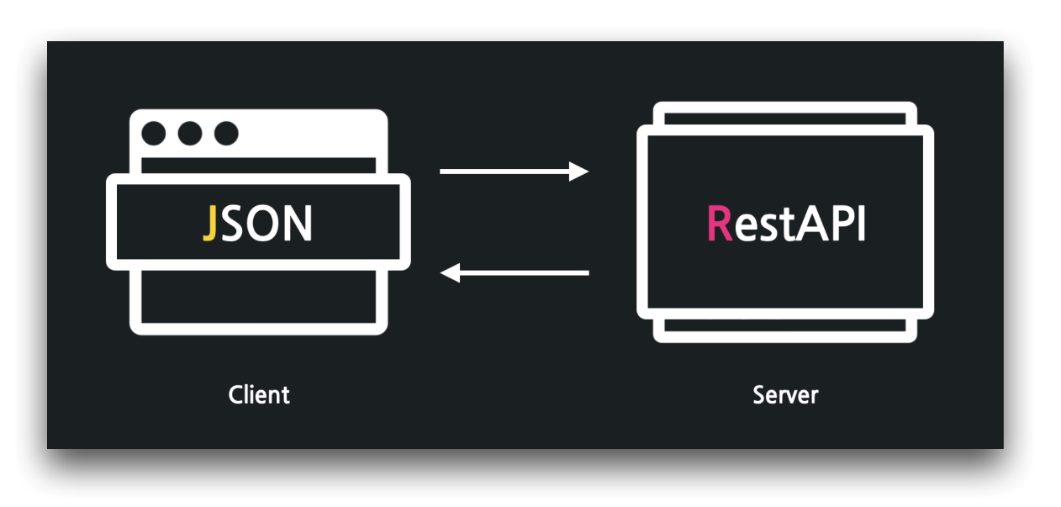

**07:34 GET 요청과 응답 성공 - Status Code 200, OK**

게시글 목록 요청

1. GET https://jsonplaceholder.typicode.com/posts

1번 게시글 상세 요청

1. GET https://jsonplaceholder.typicode.com/posts/1

**09:11 GET 요청과 응답 실패 - Status Code 404, Not Found**

존재하지 않는 게시글 요청

1. GET https://jsonplaceholder.typicode.com/posts/101

**10:11 HTTP 요청과 응답 분석 - http header, http body**

HTTP 분석

1. GET /posts/101 HTTP/1.1
2. Host: jsonplaceholder.typicode.com
3. HTTP/1.1 404
4. date: Fri, 22 Apr 2022 11:25:38 GMT
5. content-type: application/json; charset=utf-8
6. content-length: 2
7. x-powered-by: Express
8. x-ratelimit-limit: 1000
9. x-ratelimit-remaining: 999
10. x-ratelimit-reset: 1650626787
11. vary: Origin, Accept-Encoding
12. access-control-allow-credentials: true
13. cache-control: max-age=43200
14. pragma: no-cache
15. expires: -1
16. x-content-type-options: nosniff
17. etag: W/"2-vyGp6PvFo4RvsFtPoIWeCReyIC8"
18. via: 1.1 vegur
19. cf-cache-status: MISS
20. expect-ct: max-age=604800, report-uri="https://report-uri.cloudflare.com/cdn-cgi/beacon/expect-ct"
21. report-to: {"endpoints":[{"url":"https:\/\/a.nel.cloudflare.com\/report\/v3?s=nlSvnyRvizeJezp%2FuamEsuKMfkjcfbL39VakxznvU4QQLvaegKBiiRr8z7OYpPraCD5PS3Uk2HG3ZpOTH96SXXWHCDQimXIpds41kOTNjxsxzEnWzo0F3Y6F5Ltc4sD%2FLZyNb5l7m9rM%2F27DbjTn"}],"group":"cf-nel","max_age":604800}
22. nel: {"success_fraction":0,"report_to":"cf-nel","max_age":604800}
23. server: cloudflare
24. cf-ray: 6ffdfff84eeef8b3-NRT
25. alt-svc: h3=":443"; ma=86400, h3-29=":443"; ma=86400
26. {}

**12:07 POST 요청과 응답 성공 - Status Code 201, Created**

새 게시글 생성 요청

1. POST https://jsonplaceholder.typicode.com/posts
2. {
3. "title": "오늘은 왠지..",
4. "body": "치킨을 먹고 싶어라..!"
5. }

**13:56 POST 요청과 응답 에러 - Status Code 500, Internal Server Error**

잘못된 새 게시글 요청

1. POST https://jsonplaceholder.typicode.com/posts
2. {
3. title: "오늘은 왠지..",
4. body: "치킨을 먹고 싶어라..!"
5. }

**15:13 PATCH 요청과 응답**

게시글 수정 요청

1. PATCH https://jsonplaceholder.typicode.com/posts/1
2. {
3. "title": "asdfasdfadf",
4. "body": "123123123"
5. }

**16:13 DELETE 요청과 응답**

게시글 삭제 요청

1. DELETE https://jsonplaceholder.typicode.com/posts/10

**🔥 구글링 훈련하기**

* REST API란
* HTTP 메소드
* HTTP 상태 코드
* HTTP 요청 응답
* HTTP 메시지 구조